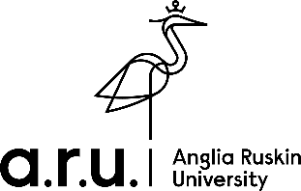

**Alumni of the Month Feature Questions**

**Tell us about yourself**

**What is your fondest memory of Anglia Ruskin University?**

**What has been your favourite job?**

**In one word, how would you describe Anglia Ruskin University?**

**How did your time at ARU help you?**

**What did you love about your chosen course?**

**What advice would you give to current students as they’re preparing to graduate?**

**What do you know now that you wish you had known whilst studying?**

**Who was the biggest influence on your career?**

**What advice would you give your younger self?**

**Tell us something about yourself that most people don’t know.**

**What’s next?**